Web programming
Week 4
Date : 12 October 2026

Html tags

Written code similar to create a webpage in the slide :
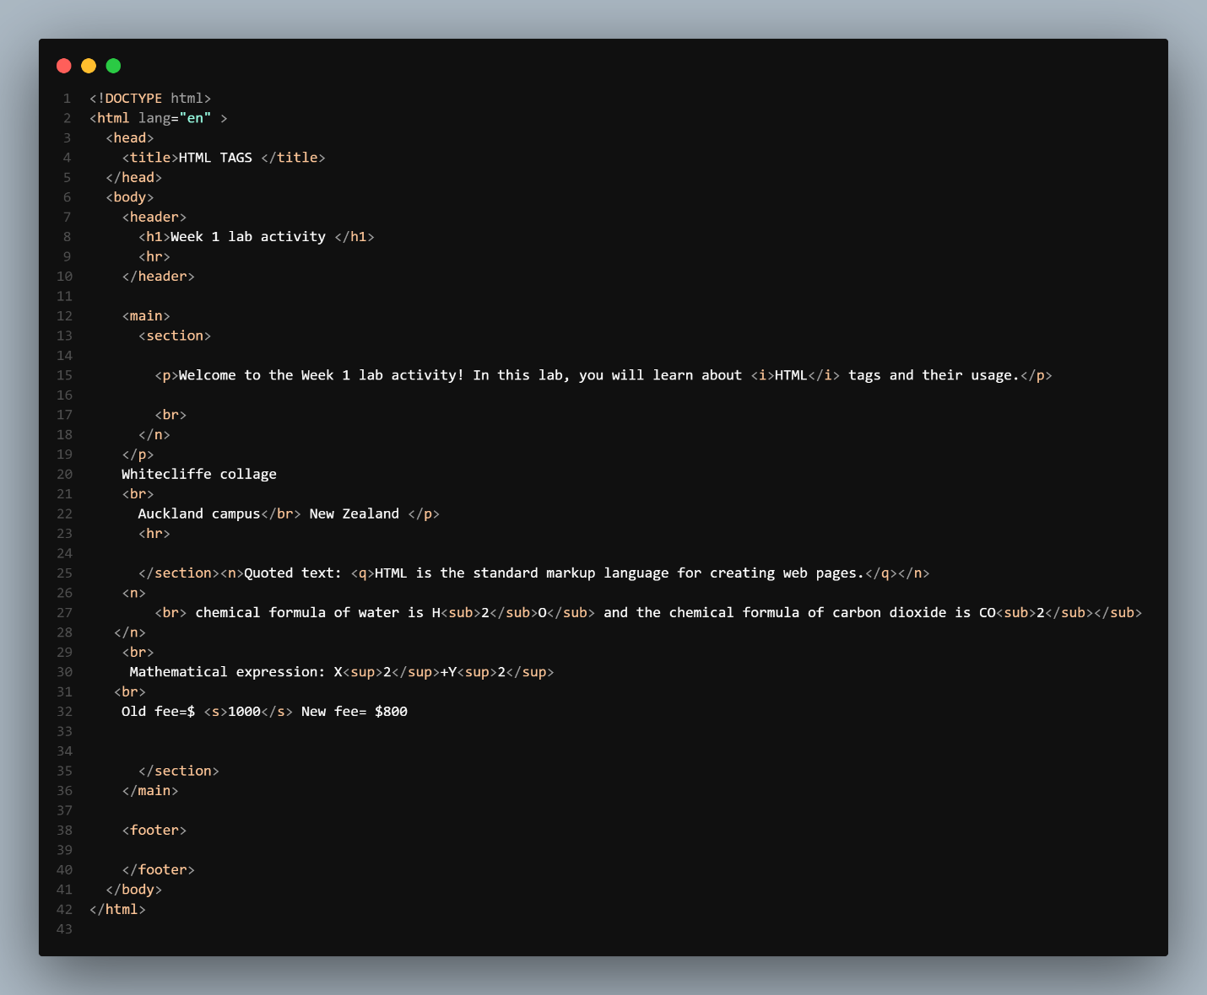
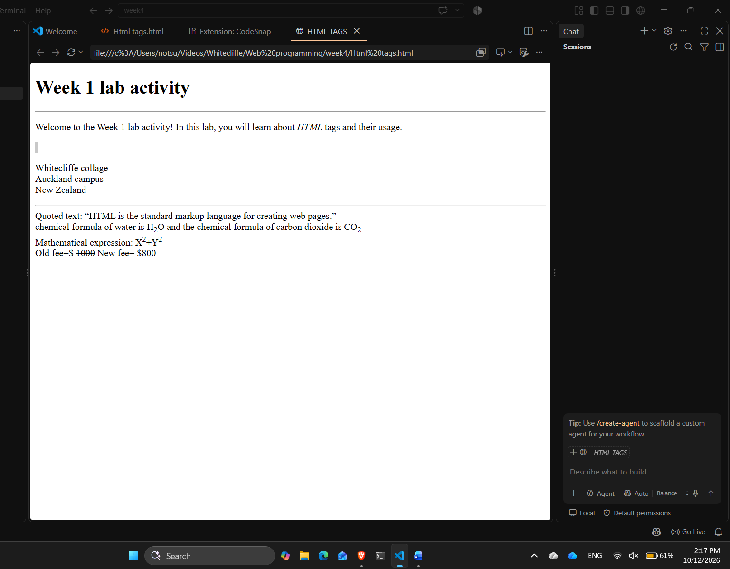
The outcome of the written code :

